Charging Statistics

# Introduction

Here I examine how electric vehicles affect peaks in power consumption. By exploring the time and frequency of chargings as well as their correlation with power usage peaks, it is the goal of this section to shed some light on the pressures electric vehicles assert on the grid.

# Timing

## Time of day

Figure 1 shows the number of charging events in the data which coincide with each hour of the day. There are two distinct peaks. The morning peak between 0200 and 0500 drops off sharply between 0500 and 0600. The afternoon peak is less dramatic, peaking relatively quickly after 1500, then decreasing gradually from 1900 out.

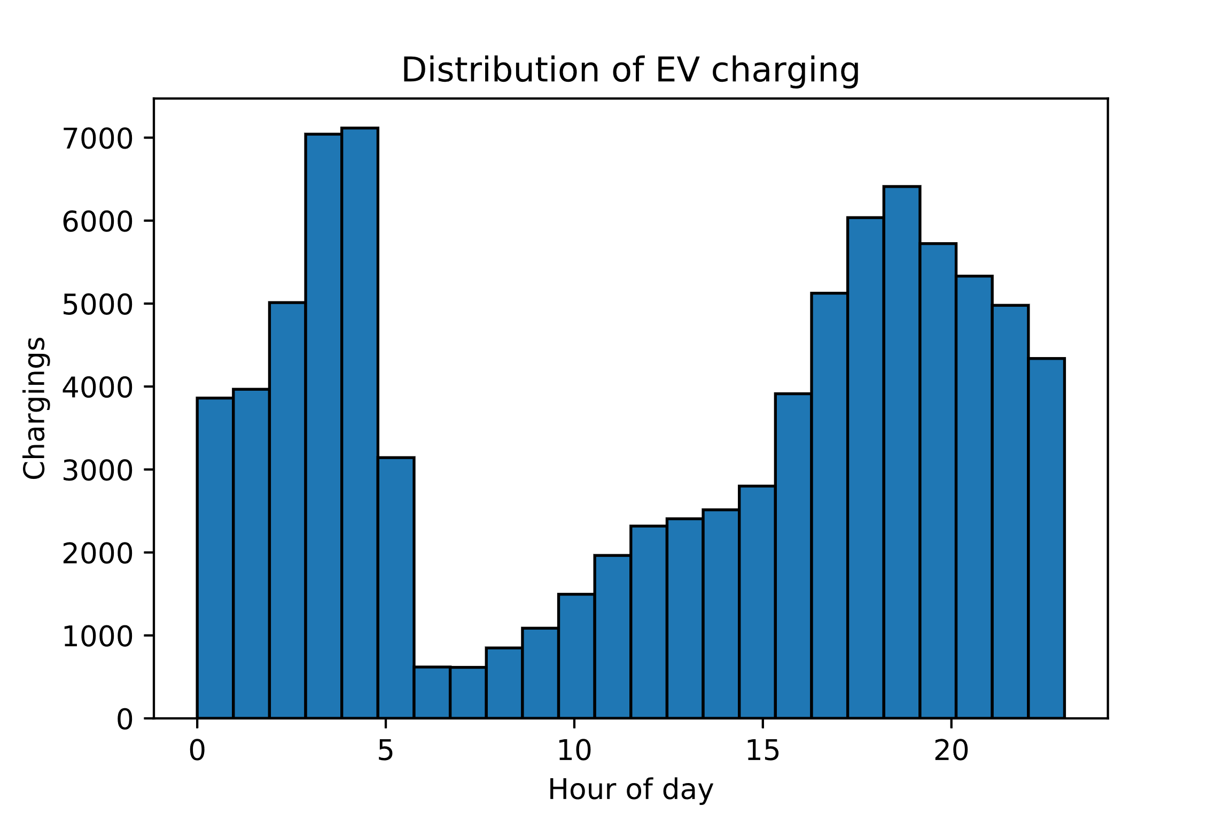

Figure 1: The number of charging signatures in the data which are active at each hour of the day.

The afternoon peak and prenoon valley correspond well with expectation: People charge their cars after they come home from work. The even larger pre-morning peak is more surprising but is likely due to programmed charging devices charging the car before the workday. When looking at the most common charging time per household in figure 2, the pre-noon valley becomes even more distinct. Additionally, the afternoon peak is split into an afternoon peak around 1700 and an evening peak around 2100.

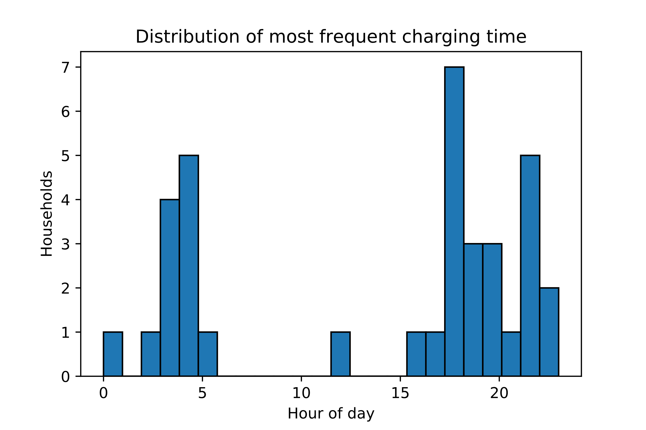

Figure 2: The distribution of the mode charging time of day for each household in the data.

## Charging duration

According to the Norwegian electric vehicle owner’s association (Norsk elbilforening), the average battery size for common EVs sold in Norway in 2016 was 33 kWh (figure 3). Assuming similar battery sizes in Texas and an average charging rate of 5 kW, a very rough estimate puts expected typical charging times at somewhere below 6 hours. However, as figure 4 reveals, the typical charging time for most houses in the data lies between 1.5 and 3.5 hours.

Figure 3: Battery capacity of common electric vehicles sold in Norway in 2016. The largest batteries, at 90 kWh, belong to Tesla models S and X. The smallest, at 7 kWh, belongs to the four-wheel motorbike Renault Twizy.

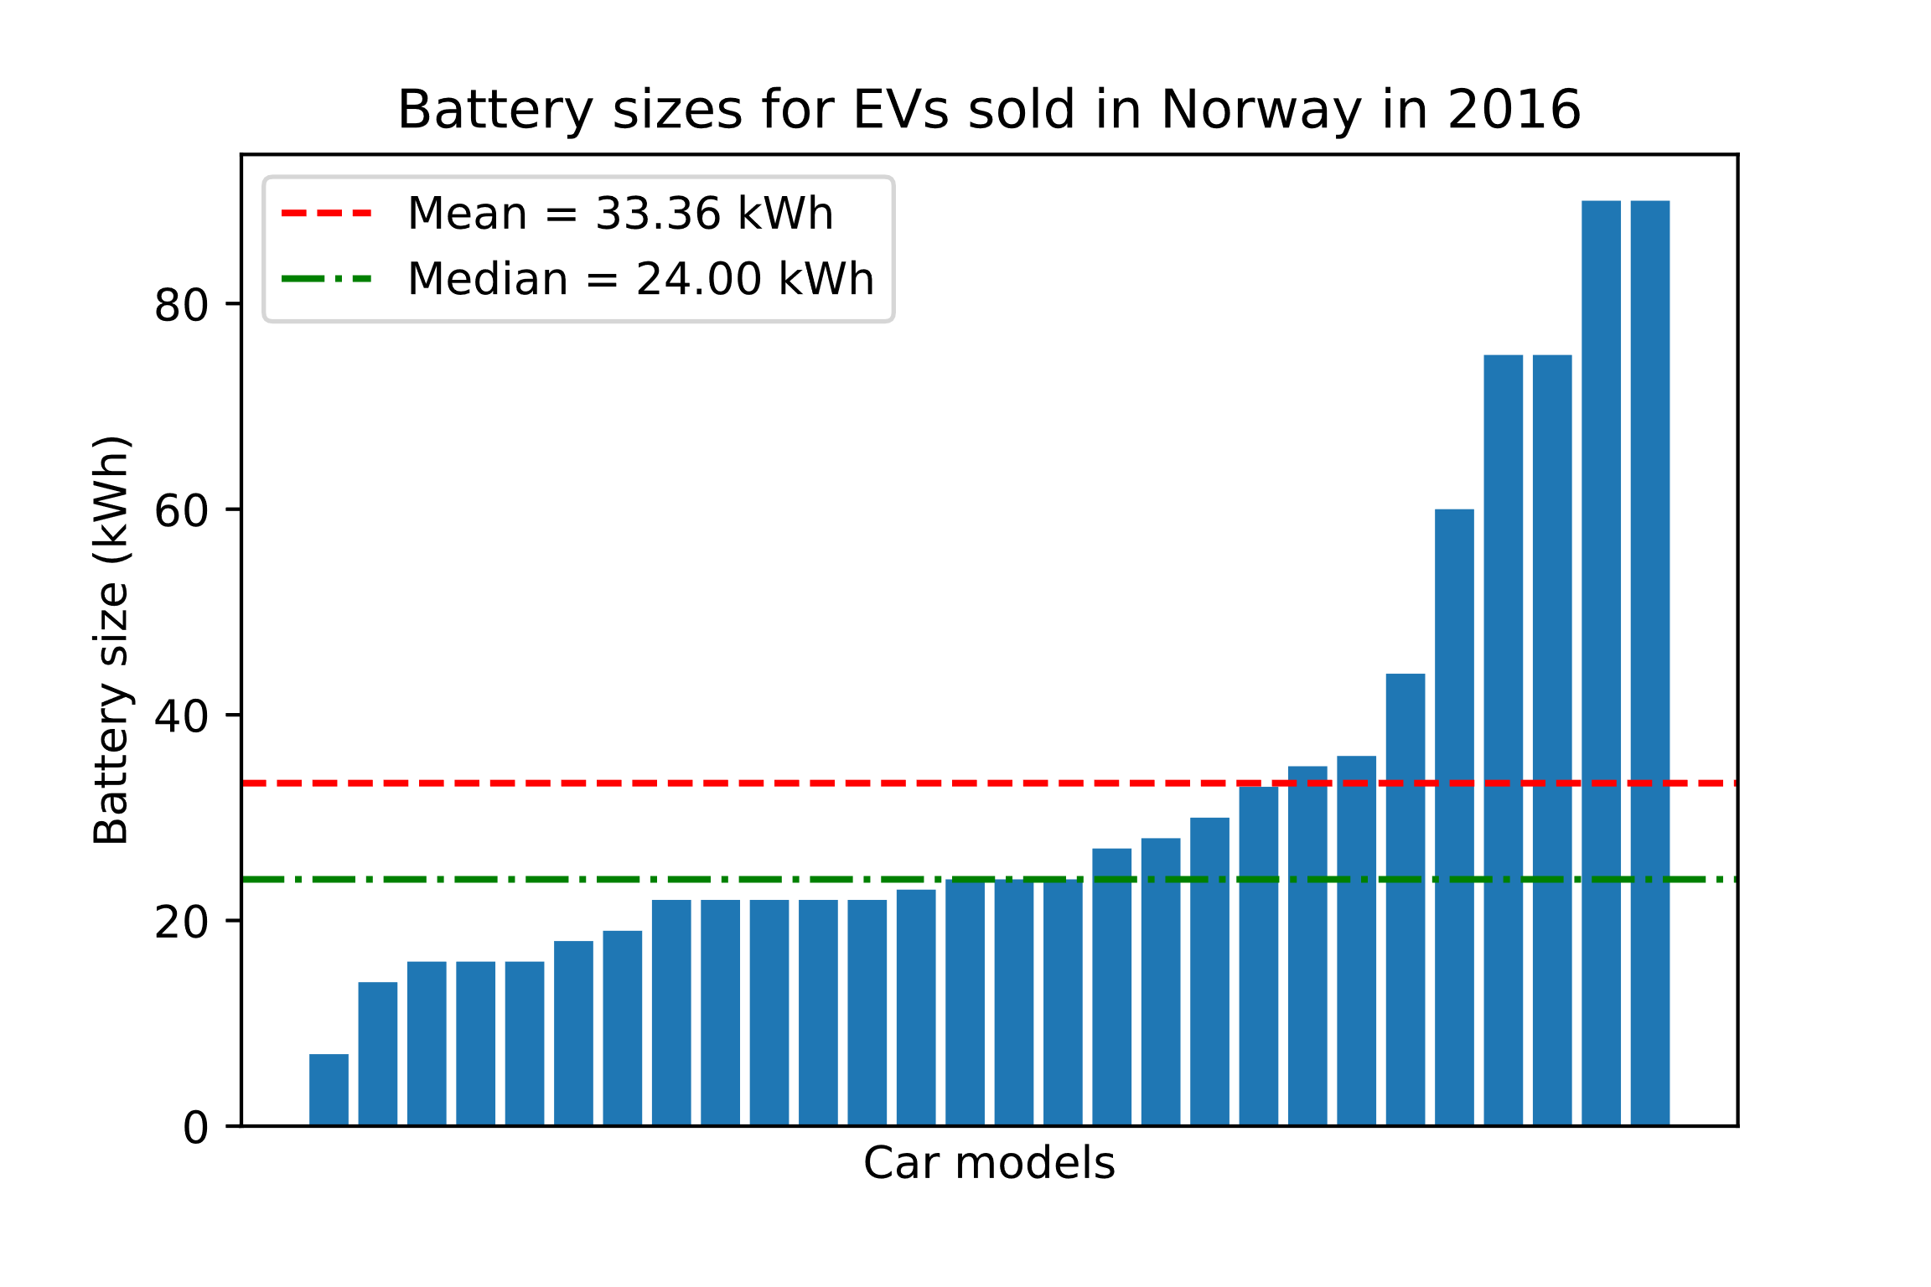

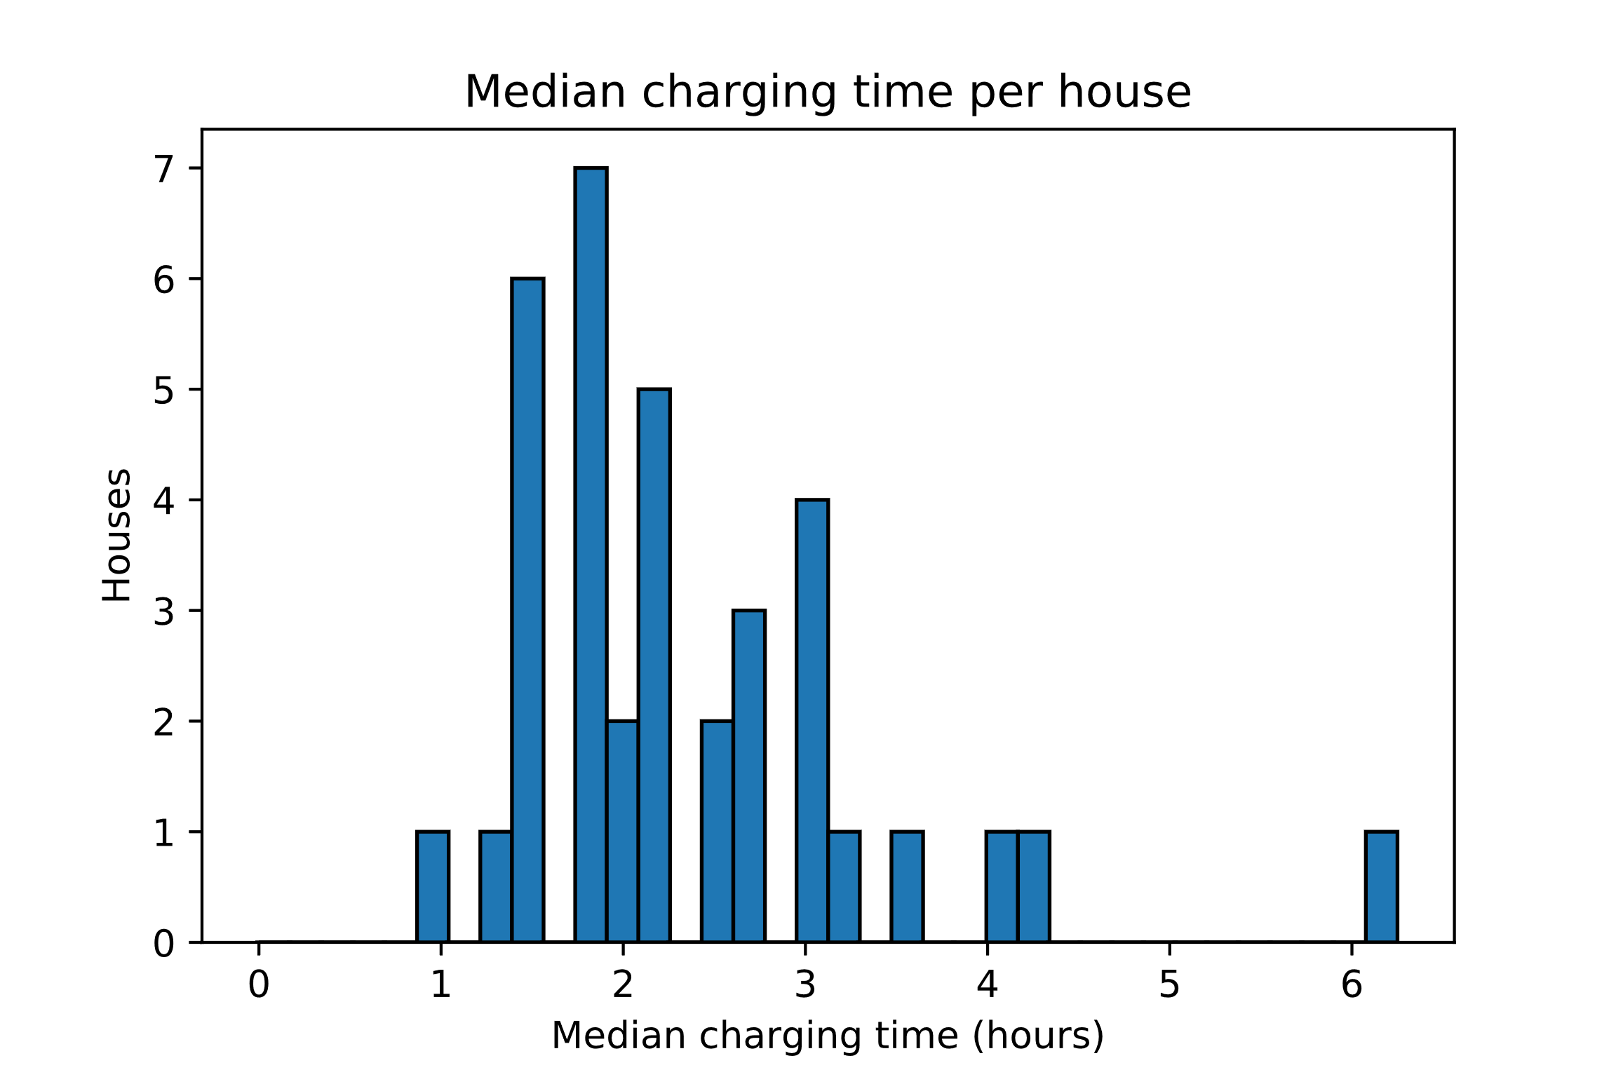

# Charging frequency

How often owners of electric vehicles charge their cars may be a useful statistic e.g. for determining whether an unknown household has an EV. For this purpose, it is useful to examine the duration of the periods between charging events. Figure 5 shows the distribution of such periods from the data. For clarity, figure 6 shows the inter-charging periods sorted by length, clearly displaying terraces around each 24-hour multiple. For both figures, all inter-charging periods exceeding one week in duration have been left out. This amounts to less than 2% of such periods.

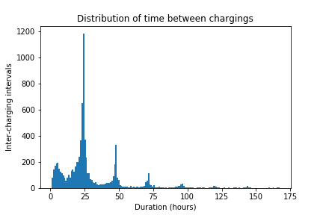

Figure 5: The distribution of the duration of the periods between two charging events in a single household. Periods exceeding one week have been left out.

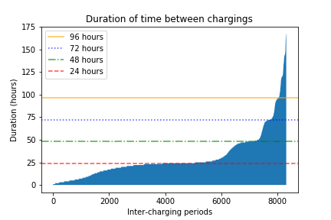

Figure 6: The same periods as in figure 5 sorted by duration. Periods exceeding one week have been left out. Horizontal lines indicate 24-hour multiples.

Figure 4: Median charging time per house. The typical charging takes for most houses a perhaps surprisingly short time.

Both figures show that in general, car owners follow a 24-hour charging cycle, with most charging every day. In the data, 61.1% of houses has a median inter-charging period of less than 24 hours, while 86.1% of houses has one of less than 48 hours. Figure 7 shows the distribution of inter-charging periods from each house as box plots. Grey and white bands indicate 24-hour intervals. Shows that the median for most houses lie around the 24-hour mark.

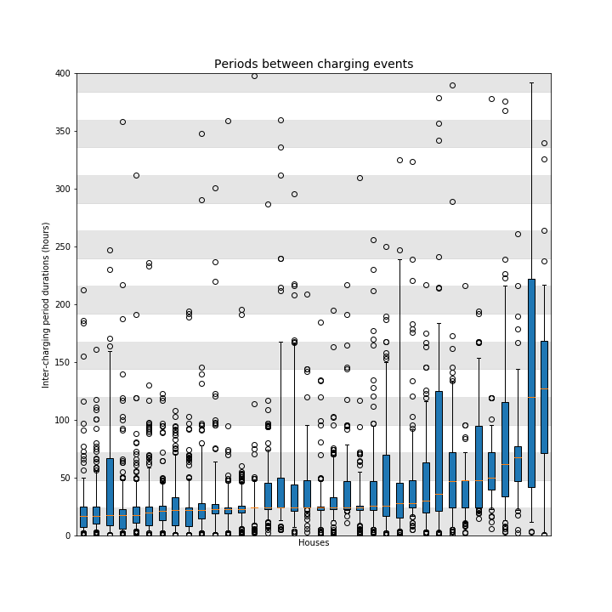

Figure 7: Each box plot represents the distribution of the duration of time between chargings for each house in the data. Most houses show a median inter-charging period duration of around 24 hours. Some outliers have been left out of the figure.

# EV Peak Contribution

Another interesting metric is how much EV charging contributes to the peaks in power use for a household. If EV charging constitutes a large proportion of the grid peaks, the viability of EV discovery methods increases significantly. Figure 8 shows that while the median household owes a large part of its net power drain peaks (defined as regions of measurements above three standard deviations from the signal mean) to EV charging, the proportion varies greatly, with some houses owing almost none of their peaks to EVs.

Figure 6: The proportion of contiguous periods with net power drain greater than three standard deviations from the mean corresponding to EV charging events for each house.

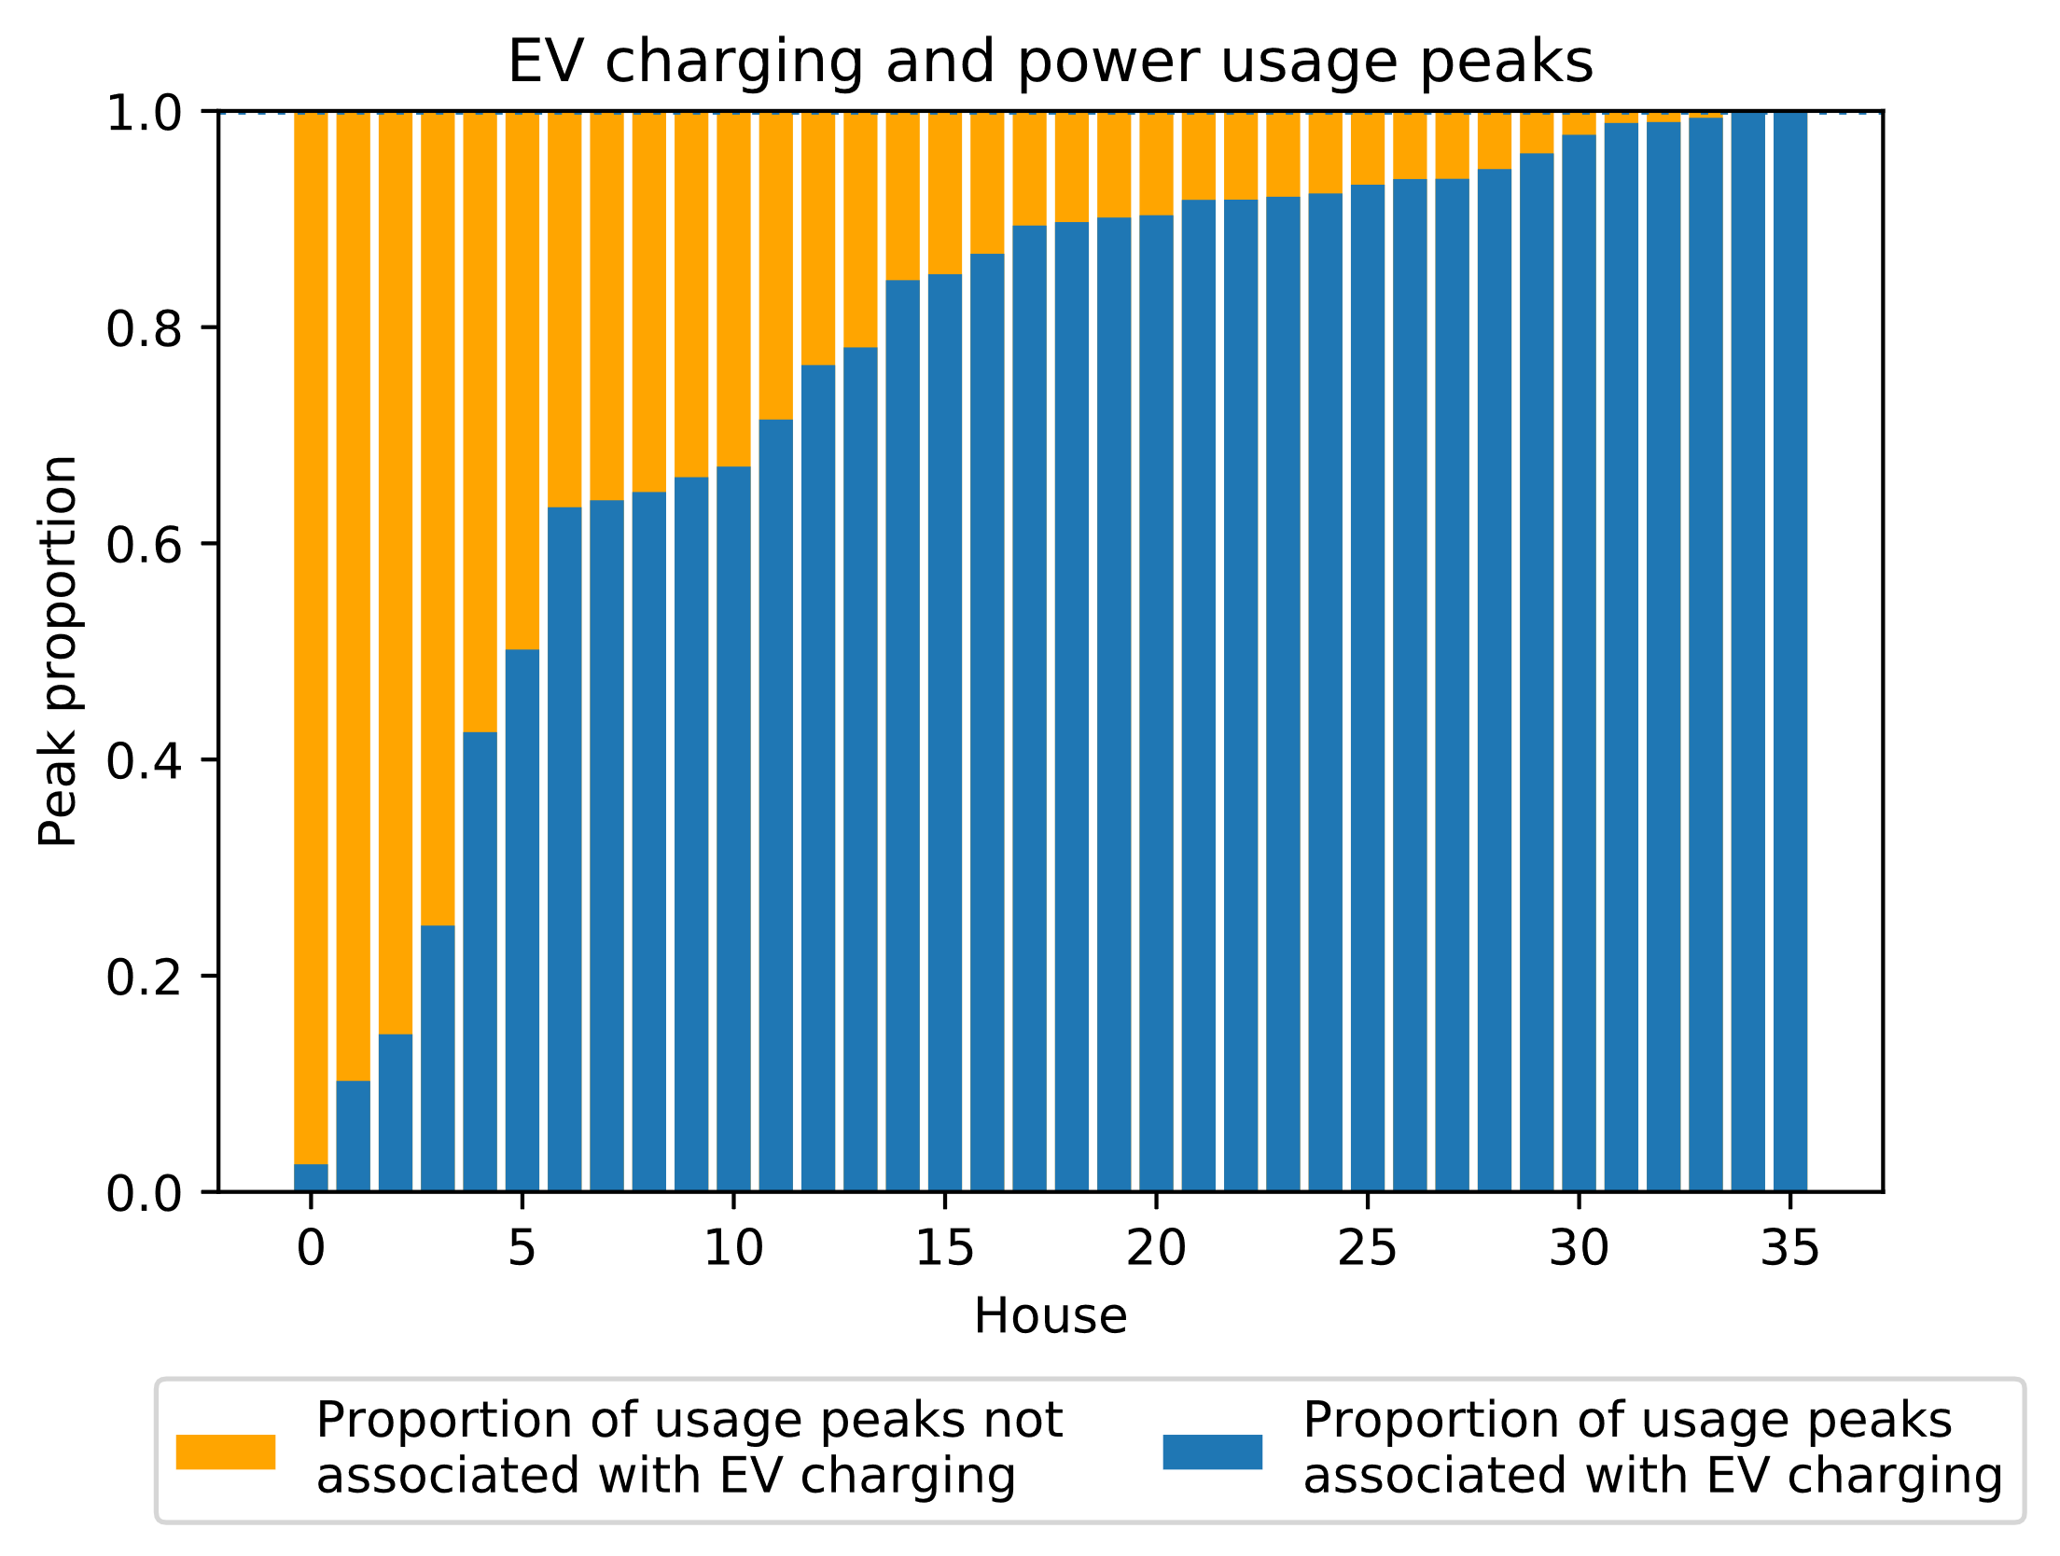

# Discussion